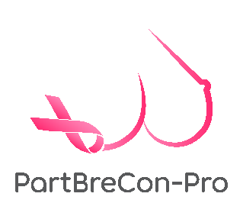
Mr Amit Agrawal
Consultant Oncoplastic Breast Surgeon
Cambridge University Hospitals NHS Trust
Cambridge
CB2 0QQ

Dear Amit,

Re: PartBreCon-Pro study: PARTial BREast RECONstruction with Chest Wall Perforator Flap, a PROspective Study of Clinical and Patient Reported Outcomes

This is to confirm that the “Name of your Hospital” supports the PartBreCon-Pro study. This international multi-centre study will provide the first prospective evidence in partial breast reconstruction following the excision of relatively larger breast cancers while maintaining preserved breast aesthetics.

The study will elaborate on surgical and patient-reported outcomes and understand surgical and radiotherapy factors that lead to such outcomes, as measured with appropriate tools. This will lead to immediate patient benefit by demonstrating current prevalent practice data and suggesting good practice.

We look forward to collaborating with you on this project.

Yours truly,

Signature

Mr/Ms
Consultant Oncoplastic Breast Surgeon

Date :

